**Python Timer Design Document**

**Description**

A timer application that has a configurable duration and name that can be edited or deleted.

This application will let the user create timers with the following inputs:

* Timer Name
* Hour
* Minute
* Seconds

This application will let the user edit created timers through:

* Edit timer
  + Edit timer has the same inputs as create timer
* Delete timer
  + Confirmation prompt

**Data Structure**

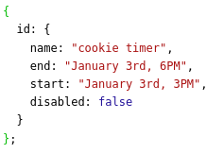

**Server endpoints/API**

**/**

**Type:** GET

**Description:**

Home page. User should be on this page at all times.

**Return:** index.html

**/get_timer**

**Type:** GET

**Description:**

Not a page. Server endpoint, return dictionary of timers.

**Return:**

timers: Timers is an object of timers.

**/create_timer**

**Type:** POST

**Description:**

Not a page. Server endpoint, given name, end, start, disabled, write data to timers.

Write to data:

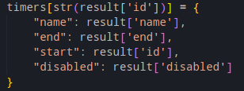

**Input (In an object/dictionary):**

“id”: ID of the timer

“msg”: Name of the timer

“time”: End time time of the timer

“sessionId”: Start time of the timer

“disabled” : Whether the timer is disabled or not

**Return:**

timers: Timers is an object of timers.

**/edit_timer**

**Type:** POST

**Description:**

Not a page. Server endpoint, given id, name, end, start, disabled, update data to timers.

Write to data:

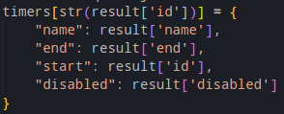

**Input (In an object/dictionary):**

“id”: ID of the timer

“msg”: Name of the timer

“time”: End time time of the timer

“sessionId”: Start time of the timer

“disabled” : Whether the timer is disabled or not

**Return:**



**/delete_timer**

**Type:** POST

**Description:**

Not a page. Server endpoint, given id, disabled, update data to timers.

Write to data:

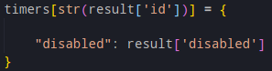

**Input (In an object/dictionary):**

“id”: ID of the timer

“disabled” : Whether the timer is disabled or not

**Return:**

